OFFICIAL

National road safety data working group

National Road Safety Data Collection & Reporting Framework

June 2025

# Introduction

Through the National Road Safety Strategy 2021-2030 (Strategy) and the National Road Safety Action Plan 2023-2025 (Action Plan), Australian governments have committed to working together to prevent deaths and serious injuries on Australia's road transport system. Responsible, secure and seamless sharing of road safety data between governments is an efficient use of resources and will help deliver better road safety outcomes. Continuous improvement of national data and monitoring of road safety across the whole system will be a key to achieving reductions in road trauma by empowering high-quality research, evidence-informed agenda setting and policymaking, and the deployment of effective and appropriate countermeasures.

Governments have worked together to develop this National Road Safety Data Collection and Reporting Framework (the Framework) and National Road Safety Dataset (NRSD).

The Framework and NRSD provide a focused plan through to 2030, to improve the availability, completeness and consistency of road safety data that governments need to:

* Report on the Strategy and associated action plans, and
* Inform their future planning and policy development for road safety in Australia.

Together these documents set out the agreed foundation for continued sharing of road safety data and prioritised data improvements.

# Purpose of the Framework and NRSD

The Framework and NRSD will:

* Guide and document the development of a shared set of nationally consistent road safety data, and
* Prioritise improvements to road safety data collection and reporting efforts.

A clear plan for the development and improvement of a NRSD over time will also help to inform the selection and development of robust measures for future strategies and action plans. Measures can be selected that are planned to have data available to enable progress reporting.

# Timing

The Framework and NRSD set out an ambitious undertaking to improve road safety data, that will be an ongoing, iterative process.

Data improvements will be planned and staged for the life of each Strategy, and will consider a time horizon beyond the current Strategy. Each improvement will build on the last to deliver a cycle of continuous improvement, from filling data gaps to exploring new data.

Data improvements will be prioritised using these broad timeframes:

|  |  |
| --- | --- |
| Priority | Timeframe |
| Early action | Action in 2024-25 |
| Medium term | Action in 2026-27 |
| Longer term | Action in 2027-30 / post-2030 |
| N/A | Data quality is considered fit for purpose /  Cost to address under current strategy is not feasible |

# Governance

Through a process of collaboration and consensus, the Road Safety Data Working Group (RSDWG) will agree on priorities for new data collection or data quality improvements. Agreed priorities will be incorporated into the RSDWG annual work program. Data priorities may also be influenced by external inputs, such as road safety stakeholders, governments, ministerial direction, or other developments in national road safety.

The RSDWG is the primary inter-jurisdictional forum for coordinating the development of national datasets, and managing operational matters relating to national road safety data. It reports to the Intergovernmental Steering Committee on Road Safety (ISCRS).

In addition to the Framework and NRSD, the RSDWG also administers the Intergovernmental Data Sharing Agreement for Road Safety Data (DSA).

The Framework and NRSD are designed to complement the DSA and reduce duplicated data requests to states, by setting out governments’ shared goals to improve the quality and availability of road safety data in additional detail. As data is improved or new data is shared over time according to the plan set out in the Framework and NRSD, the results of that work are expected to be added to the DSA as appropriate.

Where the Framework or NRSD conflicts with the DSA, the DSA will take precedence. There may also be instances, such as in the purchase of commercial datasets, where data is included in the NRSD but not in the DSA.

# Data Types and Themes

The NRSD is made up of three types of data, each organised into themes:

* Crash data
* System data
* Contextual data

These data may contain a mix of structured and non-structured data, including spatial data. Fields and agreed road base maps will also be included in the NRSD to enable linking between different datasets across themes and easy analysis and extraction of data.

## Crash data

This data type is specific to the road safety agenda and is collected and used primarily by road safety stakeholders. Data under these themes is the main focus of the NRSD and efforts to improve road safety data quality and completeness.

|  |  |
| --- | --- |
| Theme | Notes |
| Crashes | Information about the time, date, location, impact (deaths and injuries), type and causes of a crash. |
| Vehicles | Information about the vehicle(s) involved in a crash, including VIN, size, parked, speeding. |
| Persons | Information about the people involved in a crash, behaviours, and the impact on them including age, sex, admitted to hospital, drug and alcohol tests, seatbelt, helmet, driver/passenger, position in the vehicle |

## System data

This data type is useful for road safety progress reporting, research, policy and program design, but is also collected and used more widely across transport portfolio agencies. Road safety stakeholders are not generally the custodians of this data, but they often work closely with the custodians of this data and can have some influence on the availability and quality of this data.

|  |  |
| --- | --- |
| Theme | Notes |
| Investment (Infrastructure) | Information about the amount and type of investment in road safety infrastructure as well as general road infrastructure and maintenance. |
| Road Infrastructure | Information about each segment of road:   * inventory of road assets (number of lanes, type of surface, width etc), * condition of road assets, * restrictions on road assets (e.g. speed limits, heavy vehicle access, road closures). |
| Road Usage | Information about the amount of traffic on each segment of road, including Average Annual Daily Traffic estimates and actual traffic counts. Includes operating speeds and other measures of typical behaviour or road use |
| Road Risk Ratings | Information about the modelled level of crash risk for the design and condition of each segment of road. |
| Enforcement | Information about enforcement activities. |

## 

## Contextual data

This data type is also essential and widely used by road safety stakeholders, although they are not generally involved in its collection or curation. It is widely available and good quality.

|  |  |
| --- | --- |
| Theme | Notes |
| Population | Openly available in good quality from ABS |
| Demographics | Openly available in good quality from ABS about age, gender, information about level of disadvantage such as from Socio-Economic Indexes for Areas (SEIFA), etc. |
| Geographies | Urban, Regional, Remote. State, LGA. SA1, 2, 3 etc. Openly available in good quality from ABS. |
| Vehicle fleet | General information about registered and unregistered vehicles, including size, age, make, model, safety features. |
| Licensing | Information around licensing numbers, types and processes |

## Data sources

The NRSD is expected to include data from a range of sources introduced over time, including:

* Data shared by governments;
* Data from industry; and
* Purchased data.

## Privacy and levels of access

The NRSD will contain a mix of:

* Open data, and
* Restricted access data.

Where restricted data may be of a sensitive nature, rules may be established for data access, release and privacy considerations.

# Data development priorities

Each year as part of its workplan, the RSDWG will propose and discuss data priorities. Data priorities will be agreed for the present year, allowing these data to be immediately prioritised for improvements through increased sharing, collection changes, purchase, or otherwise acquired for inclusion in the NRSD.

The RSDWG will also propose priority datasets that are expected for the following year, giving visibility of priorities over a two-year horizon. While these second year priorities may change in response to emerging issues and the changing road safety environment, the aim is to provide a useful indication of upcoming work to both the RSDWG and ISCRS. This will assist with stakeholder consultation, enable forward planning for the data improvements, and streamline the next year’s discussion and agreement of data priorities.

At the commencement of this Framework, the following indicative data priorities were identified by the RSDWG:[1]

* Speed
* Injury
* Mental health and suicide
* Micro mobility
* Timeliness of road safety data
* Indigenous status

*Figure 1* below demonstrates for illustrative purposes only, how a data development priority could be executed.

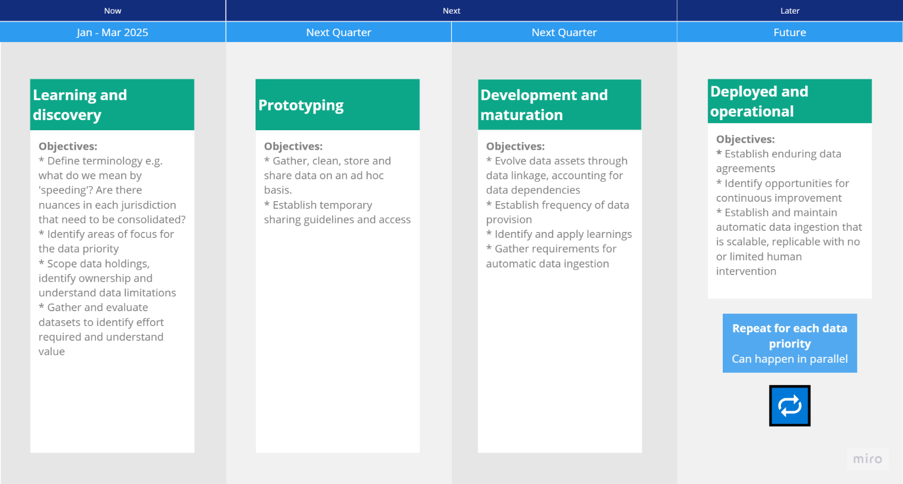

Figure 1: Example roadmap of data development priorities being executed

# Opportunities

## Open data

The RSDWG will consider the potential for better utilisation, sharing and enhancement of datasets currently collected and shared; collected but not shared, or where data quality can be enhanced. The RSDWG may also consider whether additional datasets or fields could be made public.

## Efficiency, timeliness and technology

Technologies for the efficient sharing of data are becoming increasingly cost effective and secure.

Under this Framework, governments will work together through the RSDWG to identify and test more efficient ways to share and release data, including APIs and automated checking of data quality.

## Emerging data sources

Emerging data sources are increasingly offering new opportunities for governments to access useful information about roads and vehicles. Under this Framework emerging data sources for key data development priorities will be monitored by the RSDWG. This will include annual review of their potential to improve or enhance the NRSD and pilot projects where appropriate.

# Document Control

Refer to the following table for the approver and latest version of this document.

|  |  |  |  |
| --- | --- | --- | --- |
| Version | Release date | Approver | Reason for update |
| 1.0 | Jun 2025 | Intergovernmental Steering Committee on Road Safety | Initial release of document. |

1. These data priorities emerged as points of consensus during discussions at the RSDWG meeting of 4 July 2024. They are intended to be general and indicative points of departure, which will guide future discussions of the RSDWG as data improvement projects are scoped, agreed, prioritised and included in the forward workplan.